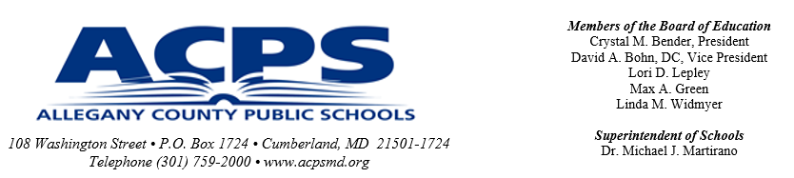

March 2026

Dear Parent/Guardian and Student:

The middle school schedule is composed of courses in language arts, mathematics, science, social studies, creative arts, and co-curricular. Students will be appropriately placed for instruction in math, language arts, science, and social studies using past performance information and teacher input.

All students are required to have four years of mathematics in Grades 9-12, even if the student is enrolled in Algebra, Geometry, or a higher math course during middle school.

Students will have the opportunity to participate in offerings such as band, chorus, or orchestra or they will be placed on a rotating schedule for mini courses such as computers/computational thinking, financial literacy, reading and math interventions, and special projects. Academic intervention and remediation are the priorities for the rotations. Students may be required to participate in tutoring and/or an ELA and/or math intervention in place of another rotation if additional academic support is needed.

For the creative arts block, sixth and seventh grade students will be enrolled in physical education/health all year long and will choose four of the following elective courses: languages and cultures of the world, art, general music, technology education, or family and consumer science. The school counselor will assign the elective that is not selected in Grade 6.

Grade 8 students will choose one option:

Option 1: Creative Arts Option: Full year of physical education/health and choice of four nine-week electives (one elective must be fine arts - either art or music).

Option 2: World Language Option: Half year of physical education/health and choice of two nine-week electives (one elective must be a fine art course - either art or music) and a full year of world language (Spanish I*)
High school credit for Spanish I will be awarded if a student passes the high school level course with a D. However, a student may retake Spanish I in high school if he/she earns a D. Please note that students must take *TWO additional years of a world language in GRADES 9-12 if the student is selecting world language as a high school completer. A minimum of two years of study in the same World Language is required for admission to the University System of Maryland.

Please review the course selection sheet to select creative arts courses for the next school year. Then, go to the website at https://acpsmd.powerschool.com/student/ to electronically enter the courses. Creative Arts courses must be selected electronically from March 17-26, 2026.

Sincerely,
Mrs. Kate Loughrie
Mrs. Kate Loughrie
Chief Academic Officer

“WHERE EVERY STUDENT CLIMBS TO HIGHER ALTITUDES”

Student Course Selection Instructions for PowerSchool

- Students should log in using their ACPS Google email and 4-digit password to the student portal https://acpsmd.powerschool.com/student/.
- Click the Class Registration link on the left-hand side menu.
- Select courses - click the pencil icon on the right to edit and view available courses.
- Please read and follow the instructions provided by the school for each requirement. Middle school students may have some courses pre‑selected for them.
- Check the boxes for the requested courses. A green checkmark indicates a requirement is met. Your selections will be based on the grade specific course selection. Please make sure all requirements are met. There should be no red exclamation marks.
- Save and Submit: Click Okay after selecting courses in each section, and finally, click Submit at the bottom of the page to lock in your requests. Additional requests may appear if your school counselor creates one for you. If you have questions about any request, please contact your school counselor.
- You may continue to log in and make changes until the course selection window is closed. The window is open from 03/17/26– 03/26/26.

2026-2027 Middle School Information Handbook and Course Selection Sheets are located on the ACPS website http://acpsmd.org. From the homepage, click the Our Families tab, then Student Resources, and navigate to the Middle School section. There, you may review course opportunities through the 2026-2027 Middle School Information Handbook or 2026-2027 Middle School Course Selection

If you have any questions about the instructions, please contact your child’s school administrator or school counselor for assistance. Thank you for working with your child to select courses for the 2026-2027 school year.

NOTE: The 2026-2027 Course Selection Sheets are PDF documents. You must have ADOBE Reader to access these documents. If they will not load for you, please visit http://adobe.com and Download ADOBE READER for FREE.

“WHERE EVERY STUDENT CLIMBS TO HIGHER ALTITUDES”

